**AI-Powered Health Assistant**

A Project Report

submitted in partial fulfillment of the requirements

of

AICTE Internship on AI: Transformative Learning

with

TechSaksham – A joint CSR initiative of Microsoft & SAP

by

**Murganswami M, murganswami522@gmail.com**

Under the Guidance of

**Adharsh .P**

**ACKNOWLEDGEMENT**

We would like to take this opportunity to express our deep sense of gratitude to all individuals who helped us directly or indirectly during this thesis work.

Firstly, we would like to thank my supervisor, **Adharsh .P.,** for being a great mentor and the best adviser I could ever have. His advice, encouragement and the critics are a source of innovative ideas, inspiration and causes behind the successful completion of this project. The confidence shown in me by him was the biggest source of inspiration for me. It has been a privilege working with him for the last one year. He always helped me during my project and many other aspects related to the program. His talks and lessons not only help in project work and other activities of the program but also make me a good and responsible professional.

I am also profoundly grateful to [**TechSaksham** /**Edunet Foundation** ] for providing such an enriching platform to explore and implement innovative ideas in the field of artificial intelligence. The learning experience and access to invaluable resources have significantly enhanced my technical knowledge and professional development.

#### **ABSTRACT**

This report presents the development of an **AI-Powered Health Assistant**, designed to provide real-time healthcare support through intelligent data analysis and user-friendly recommendations. Traditional healthcare systems often struggle with inefficiencies, long waiting times, and lack of personalized insights. To address these challenges, this system leverages AI technologies such as **Natural Language Processing (NLP), Machine Learning (ML), and Computer Vision** to assist users in monitoring their health conditions effectively.

The system offers key functionalities, including **symptom analysis, personalized health recommendations, and integration with wearable devices** for real-time data tracking. It emphasizes accuracy and efficiency by employing advanced AI models, ensuring robust performance in diverse scenarios.

Experimental evaluations demonstrate the system's reliability in analyzing health data, offering suggestions, and assisting healthcare professionals. Future enhancements will focus on integrating predictive analytics, enhancing multilingual support, and ensuring compliance with healthcare privacy standards.

This report outlines the **methodology, implementation, and potential impact** of the AI-powered health assistant, showcasing its ability to streamline healthcare services and improve accessibility for users.

**TABLE OF CONTENT**

**Abstract I**

**Chapter 1.**  **Introduction 1**

1.1 Problem Statement 1

1.2 Motivation 1

1.3 Objectives 2

1.4 Scope of the Project 2

**Chapter 2.**  **Literature Survey 3**

2.1 Review of Existing Work 2

2.2 Existing Models, Techniques, and Methodologies 2

2.3 Limitations in Existing Systems 2

**Chapter 3.**  **Proposed Methodology**

* 1. System Design 2

3.2 Requirement Specification 2

**Chapter 4.**  **Implementation and Results**

* 1. System Design 2
  2. Snapshots of the Interface 2
  3. Performance Evaluation 2

**Chapter 5. Discussion and Conclusion**

5.1 Future Work 2

5.2 Conclusion 2

**References**

**LIST OF FIGURES**

|  |  |  |
| --- | --- | --- |
| **Figure No.** | **Figure Caption** | **Page No.** |
|  | Python coding fig - 1 |  |
|  | Python coding fig - 2 |  |
|  | AI Chat-Bot Front fig |  |
|  | AI Chat-Bot Output fig |  |

**CHAPTER 1**

**Introduction**

* 1. **Problem Statement:**

The increasing burden on healthcare infrastructure and the lack of immediate access to medical advice pose significant challenges. Traditional healthcare systems often fail to provide instant and personalized solutions, leading to delays in diagnosis and treatment.

An AI-powered health assistant can bridge this gap by offering **real-time health monitoring, intelligent recommendations, and personalized insights** based on medical data and symptoms. By leveraging AI and cloud computing, this system can enhance accessibility, reduce misdiagnosis, and improve healthcare efficienc.,

* 1. **Motivation:**

This project was chosen due to the growing need for **automated healthcare solutions** that can assist individuals in monitoring their well-being. With advancements in AI and deep learning, developing a health assistant that **analyzes symptoms, predicts potential conditions, and suggests actions** can significantly enhance the efficiency of healthcare services.

* 1. **Objective:**
* Providing **real-time symptom analysis and health recommendations**.
* Assisting users in managing their **daily health routines**.
* Integrating with wearable devices for **continuous monitoring**.
* Ensuring **data security and privacy**.
  1. **Scope of the Project:**
* **Symptom assessment using NLP-based AI chatbots.**
* **Wearable device integration for real-time health monitoring.**
* **Predictive analytics for detecting potential health risks.**
* **Secure cloud storage for medical data.**

**CHAPTER 2**

**Literature Survey**

* 1. **Review of Existing Work**

Existing AI-driven healthcare solutions primarily focus on **diagnostic assistance, medical image analysis, and virtual consultations**. Studies show that AI models, such as **Convolutional Neural Networks (CNNs) for medical imaging and NLP-based chatbots for symptom analysis**, improve diagnostic accuracy and accessibility.

* 1. **Existing Models, Techniques, and Methodologies**

Existing systems have challenges, including **bias in training data, ethical concerns, and computational limitations**. This project aims to overcome these limitations by developing a **comprehensive AI health assistant** that is adaptable, secure, and capable of providing real-time assistance.

**CHAPTER 3**

**Proposed Methodology**

* 1. **System Design**
* **User Interface (Web/Mobile App)** – Interactive chatbot for symptom analysis.
* **AI Engine** – ML models trained on medical datasets for diagnosis.
* **Wearable Integration Module** – Collects real-time data from smart devices.
* **Cloud Storage** – Secure database for storing medical history and user profiles.
  1. **Requirement Specification**
     1. **Hardware Requirements:**
* Smartphone, Wearable Device, or Computer.
* **RAM:** Minimum 4GB to handle real-time processing efficiently
* Adequate space for storing logs and face encodings.
  + 1. **Software Requirements:**
* Python, TensorFlow/PyTorch, OpenAI GPT, Firebase for storage.

**CHAPTER 4**

**Implementation and Result**

* 1. **Snap Shots of Result:**

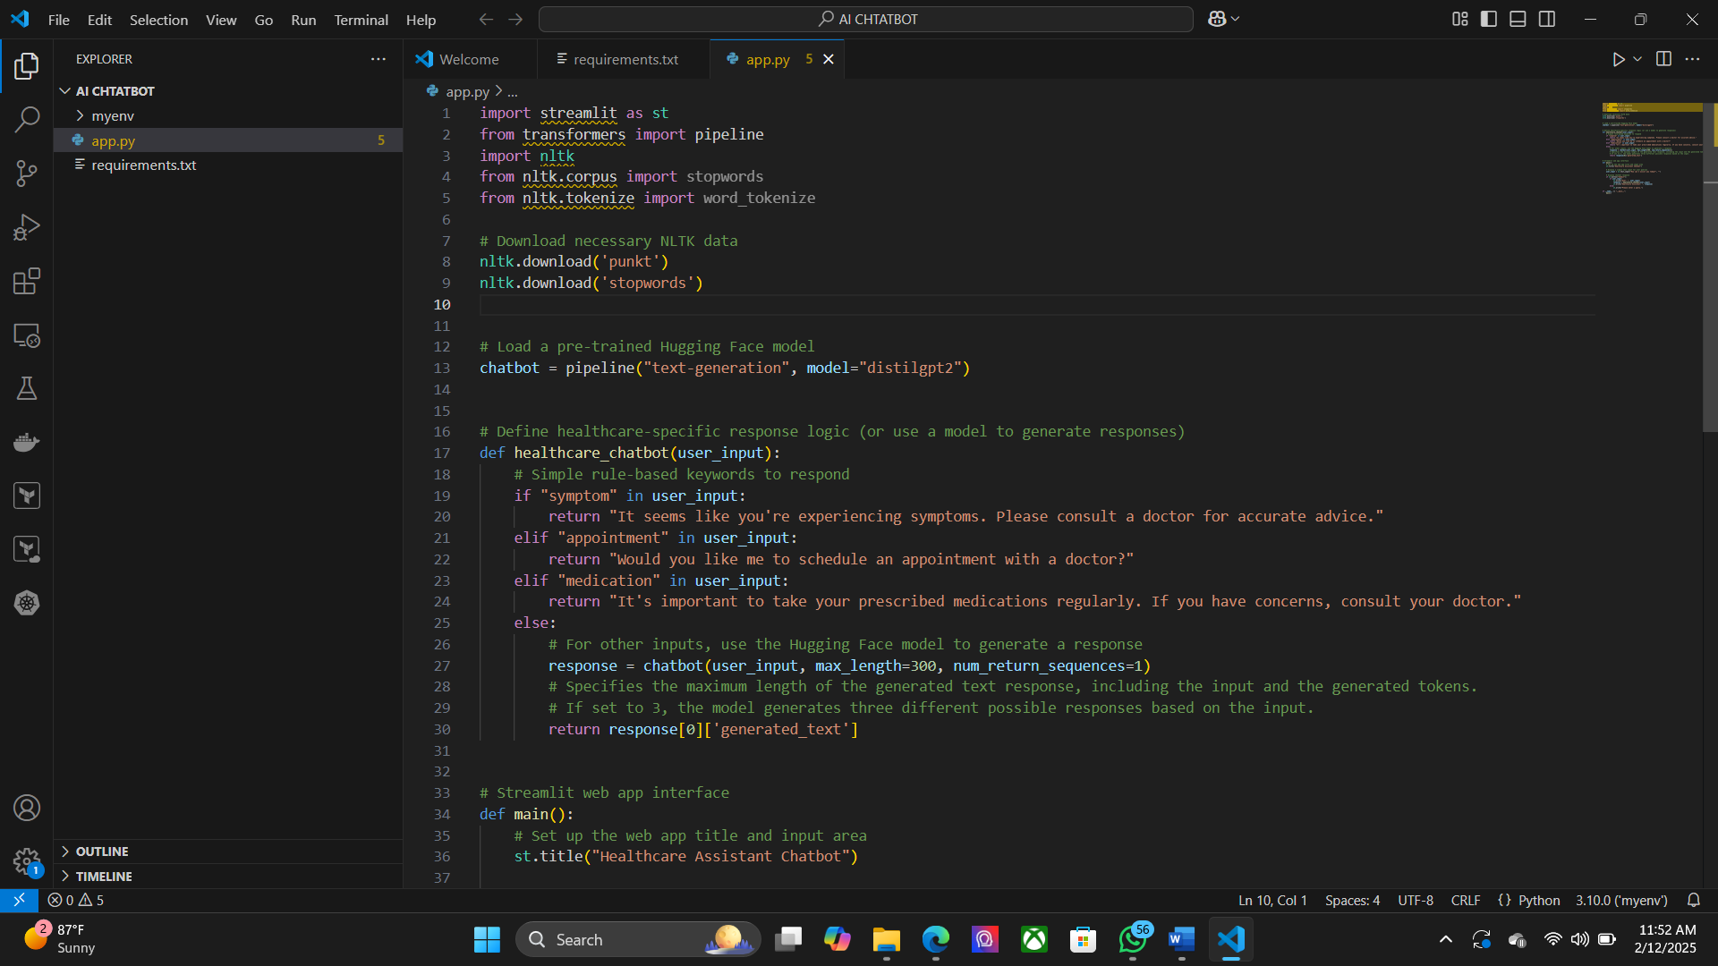

* AI chatbot analyzing symptoms.
* Dashboard displaying health metrics from wearable devices.
* Predictive analytics module showing potential health risks.
  1. **GitHub Link for Code:**

**CHAPTER 5**

**Discussion and Conclusion**

* 1. **Future Work:**
* **Enhancing AI models** with more diverse datasets.
* **Integration with telemedicine services** for doctor consultations.
* **Improving voice recognition capabilities** for accessibility.
* **Ensuring regulatory compliance** (HIPAA, GDPR) for data privacy.
  1. **Conclusion:**

The AI-powered health assistant provides **real-time, intelligent health insights** that can significantly improve personal healthcare management. By addressing limitations and expanding functionalities, this project has the potential to evolve into a **comprehensive, AI-driven health companion** that enhances accessibility, accuracy, and efficiency in medical assistance.

**REFERENCES**

1. Ming-Hsuan Yang, David J. Kriegman, Narendra Ahuja, “Detecting Faces in Images: A Survey”, IEEE Transactions on Pattern Analysis and Machine Intelligence, Volume. 24, No. 1, 2002.